**Issue 1**

Our team has changed its direction a bit, so the test will not be the key and most crucial part of our site. The crucial part is a list of faculties available in latvia, among with brief essential information about them (pricing, location, language, scolarship opportunities). The data will be imported manually from each university website and placed on our webpage in convinent way.

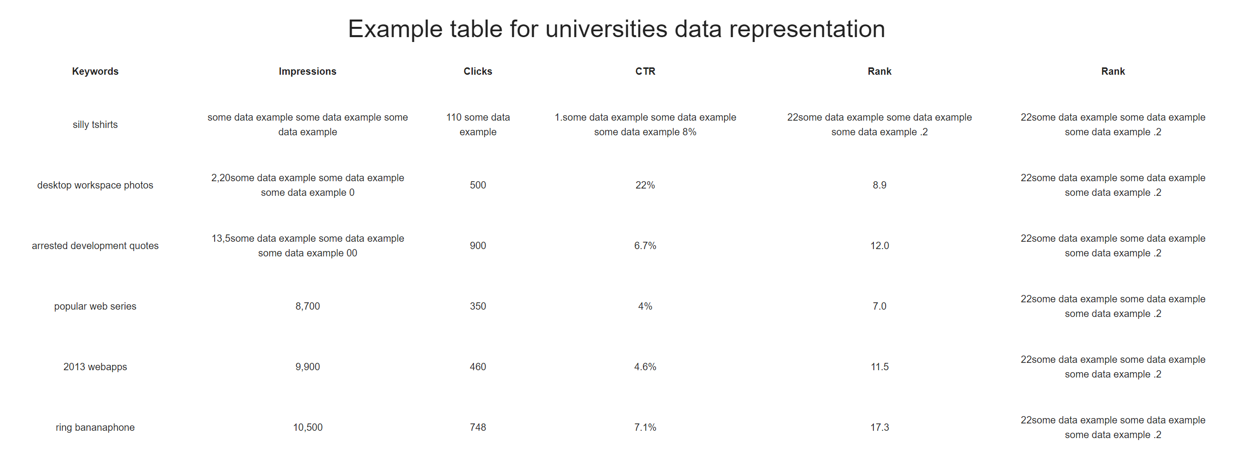

On the web site, in the step by step section, instructions for using the website and navigation, which leads to the test, will be written. Our photograph of the design shows only a sample of it. Next, a text will be invented in which it will be written what the user needs to do. And immediately after this section, there will be a button “Take the test”, after which the user will be taken to the page with the test.

Once on the test page, the user will see a brief description of how he needs to answer the questions presented to him. All test questions will be reflected immediately on the page. The question will be indicated, and below the yes or no button will be, which he will click on, based on his choice. After answering all questions (approximately 40 questions), there will be a button "Save Results". After the user clicks on it, a new page with the results will appear in front of him. On this page, a list of faculties that are suitable for the user based on the results will be indicated. Near the faculties will be indicated the universities of Latvia, in which you can get this education. And links to university pages. Now we are planning to make another webpage (because it will be both more practical and easier from a programmer’s perspective) with university info, as on a screenshot above.

**Issue 2**

(Menu items in your screenshots are named “Align with Navigator”, “History & Goals”, “Workplace”, “Personality” – it was only an example of the page design. We do not include exactly the same “titles”. In the ''four dimensions of fit'' section, we want to write which 4 factors should be considered when choosing a faculty / education. There we want to indicate that it is important that the selected faculty is in line with the interests of the individual (the user will be able to evaluate their interests by passing the test on our website). The second dimension includes the factor of the place where the user studies and the place of residence of the user (we will draw the attention of users that in Latvia you can get an education that suits him / her). The third dimension will indicate that when choosing, you need to consider the price of education (there will be a table with faculties, universities, tuition fees on the site) The fourth dimension is advice from a professional (we will indicate the data for contacting a career consultant from Bauska).

**Issue 4**

Based on the deadlines, we will create a website, all descriptions of faculties available in Latvia in it, probably the test, and its results in English. If we succeed some time before deadline, it would be good to do the same thing, but in Latvian, since it would be more convenient for the residents of Bauska, therefore the site’s effectiveness would be better.

**Issue 5**

After some new changes, the site will be useful only to residents of Latvia, since the site will have a table with various faculties, universities, tuition fees, and the number of budget place information. That is, information suitable only for residents of Latvia. Also, in ''4 dimensions of fit'', we will indicate the contacts of a career consultant in Bauska, which will connect this site with the residents of Bauska.

This information needs to be reviewed and posted to the trial balance (designs)